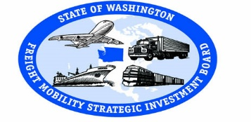
Freight Mobility Strategic Investment Board
Workshop

Tri-Cities Airport
September 14, 2017 3601 N 20th Avenue
9:00 a.m. to 2:30 p.m. Pasco, WA 99301

Agenda

9:00 Welcome and Introductions Dan Gatchet

9:15 History of Freight in Washington Brian Ziegler Presentation & Discussion

10:15 WAFAC/FMSIB Brian Ziegler

10:30 Break

10:45 FMSIB Annual Report Kjris Lund

11:00 Marine Cargo Forecast Report Chris Herman

12:00 Board Meeting Plus/Delta Brian Ziegler
- Agendas
- Venues
- Tours
- Packets
- FMSIB Staff

Working Lunch

1:00 2018 Call for Projects Brian Ziegler

1:30 Washington D.C. Trip Brian Ziegler

1:45 Subcommittee Appointments Brian Ziegler

2:00 2018 Meeting Schedule Brian Ziegler

2:30 Supply Chain Logistics Tour Port of Benton

