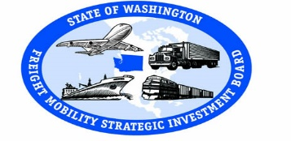
Freight Mobility Strategic Investment Board
Meeting

Tri-Cities Airport
September 15, 2017 3601 N 20th Avenue
9:00 a.m. to 1:00 p.m. Pasco, WA 99301

Agenda

9:00 Welcome and Introductions Dan Gatchet Informational

9:15 Port of Pasco Randy Hayden, Informational
Executive Director

9:30 Minutes Dan Gatchet Action

9:35 Budget Brian Ziegler Informational

10:00 Director’s Report Brian Ziegler Informational

10:15 Board Member Reports Board Action

10:30 COLA Brian Ziegler Action

10:45 Road/Rail Conflicts Study Update Brian Ziegler Informational

11:15 Project Updates Brian Ziegler Action
- Fife: I-5 / 54th Ave I/C
- Marysville: I-5 / SR 529
- Lacey: I-5 / Marvin Rd I/C

11:45 Call for Projects Brian Ziegler Action

12:00 Board Member Terms Brian Ziegler Informational

Working Lunch

12:15 Subcommittee Appointments Dan Gatchet Action

12:30 2018 Meeting Schedule Dan Gatchet Action

12:45 Next Meeting Dan Gatchet Action
November 17, 2017
Vancouver, WA

1:00 Adjourn Dan Gatchet

