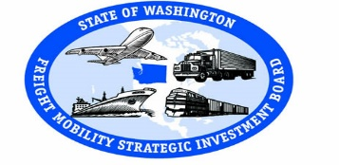
Freight Mobility Strategic Investment Board
Meeting

Port of Vancouver Boardroom
November 17, 2017 3103 NW Lower River Rd
9:00 a.m. to 1:15 p.m. Vancouver, WA 98660

Agenda

9:00 | Welcome and Introductions | Dan Gatchet | Informational
9:05 | Meeting Minutes | Dan Gatchet | Action
9:10 | FMSIB Budgets | Brian Ziegler | Informational
9:20 | Director’s Report | Brian Ziegler | Informational
9:35 | Road-Rail Study Update | Brian Ziegler | Informational
9:45 | Codifying FMSIB Revenues | Brian Ziegler | Action
9:55 | Board Member Reports | Board Members | Action
10:10 | Vancouver 32nd Arterial Ext. Project | Patrick Sweeney  City of Vancouver | Informational
10:40 | Project Definitions | Brian Ziegler | Informational
10:50 | Pierce County: Canyon Rd | Letticia Neal, P.E.  Pierce County | Action
11:15 | Marysville: I-5, SR 529 I/C | Brian Ziegler | Action
11:30 | City of Lacey: I-5, Hogum Bay Rd | Brian Ziegler | Action
11:45 | 2017 Completed Projects | Brian Ziegler | Action
12:00 | Working Lunch  FGTS Briefing & Adoption | Wenjuan Zhao  WSDOT | Action
12:40 | Planning for FMSIB Day on the Hill | Tom Trulove | Informational
1:10 | Next Meeting  January 19, 2018  Olympia, WA | Dan Gatchet | Action
1:15 | Adjourn

