

October 17, 2022

$2.4M grant will help SDOT plan for new bridge on Fourth Avenue

By JOURNAL STAFF

[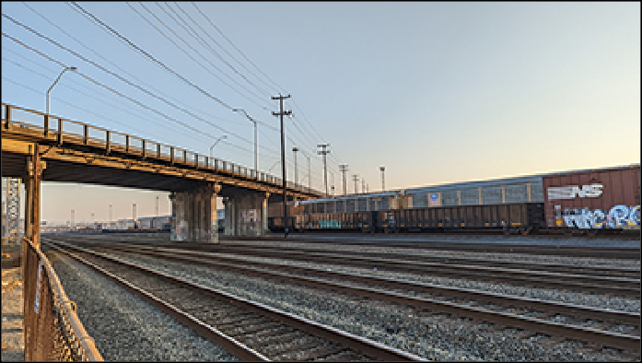](https://www.djc.com/stories/images/20221017/4thAveSBridge_big.jpg)The recent opening of the West Seattle Bridge has grabbed all the headlines lately, but there are other bridges in the city that also need extensive repair or replacement.

One of those bridges, carrying Fourth Avenue South near Costco, last week received a $2.4 million federal grant for planners to study ways to minimize traffic congestion, lessen supply chain delays, and mitigate other impacts while the bridge is being repaired or replaced. The four-lane bridge carries

north-south traffic, including high volumes of commercial trucks and 7,500 daily bus riders, over the Argo railroad yard. It's an important link for the SoDo, Georgetown and Duwamish Valley communities.

Photo by Benjamin Minnick [[enlarge]](https://www.djc.com/stories/images/20221017/4thAveSBridge_big.jpg)

**The Fourth Avenue South Bridge spans a myriad of train tracks in the Argo Yard.**

Inspectors with the Seattle Department of Transportation in 2017 found cracks in the bridge piers, which led to closing the northbound curb lane and restricting large trucks from using the southbound curb lane to help reduce further deterioration. A seismic retrofit analysis identified replacement of the bridge, built in 1933, as the most cost-effective option.

Prior to closing the curb lane, the bridge carried nearly 17,000 daily users in both directions. Since the lane closure and southbound restrictions, the number of daily users has decreased by about 25% in both directions. SDOT said this means commuters started using alternate routes or taking alternative modes of transportation to and from downtown and South Seattle.

An SDOT spokesperson said the estimated cost of the planning study is $3 million. “The study would also address other critical issues, such as seismic vulnerabilities and

construction impacts for rail and street users,” the spokesperson said. “The results of the study will

help inform the cost of the final design and construction costs associated with the preferred alternative.”

The planning study will be conducted between 2023 and 2024. The spokesperson said the schedule for engineering design and construction work is dependent on the findings from the study. “We believe that any alternative would be a significant financial investment for the city and would rely heavily upon available grant opportunities from the state and federal levels.”

SDOT will seek consultants for the planning study once the grant funds are in hand. The spokesperson said there is no set time for when SDOT will receive the grant, but the agency typically allows about six months from a formal award letter until it can start work funded by a grant.

In the near term, SDOT wants to repair the bridge so that the outside northbound lane can be reopened. It has $6.3 million budgeted for this and is finalizing the design for the repairs.

Construction is scheduled to start next year.

SDOT said the interim repair project is taking longer than expected due to coordinating with BNSF Railway and Union Pacific Railroad, which operate the rail yard below the bridge. The tricky part is the railroads own the right of way under the bridge, and because of this, SDOT is required to obtain access permits from each rail company. SDOT said the permit prohibits construction work on the bridge from the rail yard below if it disrupts rail operations, which means that SDOT would have to complete most of the interim repairs from the bridge deck.

The planning study grant is coming from the U.S. Department of Transportation's new Bridge Investment Program created under the Biden Infrastructure Law. The program funds projects aimed at reducing the overall number of bridges in poor condition, or in fair condition at risk of falling into poor condition. The program is funded in two buckets: $27.5 billion in formula funding over five years; and $12.5 billion in competitive funding over five years. Washington state will receive $653.3 million over five years in formula funding from this program.

The initial grant comes from the first round of competitive funding for planning grants, which comprises just $18.3 million of the $2.4 billion in competitive funding available for the Bridge Investment Program this year.

Copyright 2022 Seattle Daily Journal of Commerce